**Park Ticketing Management System**

**Project Report**

**<Version 5.0>**

Summer Internship (MCA364)

Degree

**MASTER OF COMPUTER APPLICATION**

|  |  |
| --- | --- |
| **PROJECT GUIDE:**  **Project Guide Name (External)**  **Project Guide Name (Internal)** | **SUBMITTED BY:**  **Prashant Shivach (TCA2163072)** |

DEC, 2022



**COLLEGE OF COMPUTING SCIENCES AND INFORMATION TECHNOLOGY**

**TEERTHANKER MAHAVEER UNIVERSITY, MORADABAD**

**ACKNOWLEDGEMENT**

To list who all have helped me is difficult because they are so numerous and the depth is so enormous.I would like to acknowledge the following as being idealistic channels and fresh dimensions in the completion of this project.I take this opportunity to thank the **College of Computing Sciences and Information Technology** of **Teerthanker Mahaveer University** for giving me chance to do this project.

I would like to thank my Principal, **Dr Rakesh Kumar Dwivedi** for providing the necessary facilities required for completion of this project.

I take this opportunity to thank our Coordinator  **Mr Amit Sharma** for his moral support and guidance.

I would also like to express my sincere gratitude towards my project guide  **Mr. Rajendra Prasad Pandey** whose guidance and care made the project successful.

**Place: Moradabad**

**Date:**

**DECLARATION**

We hereby declare that this Project Report titled **Park Ticketing Management System** submitted by us and approved by our project guide,the College of Computing Sciences and Information Technology (CCSIT), Teerthanker Mahaveer University, Moradabad, is a bonafide work undertaken by us and it is not submitted to any other University or Institution for the award of any degree diploma / certificate or published any time before.

|  |  |  |
| --- | --- | --- |
| **Project Group :** | Project Group Name/Id | |
| **Student Name:** | Prashant Shivach |  |
|  |  |  |
| **Project Guide: (External)** | Name |  |
| **ProjectGuide:**  **(Internal)** | **Mr.Rajendra Prasad Pandey** |  |

Table of Contents

1 Project Title 6

2 Problem Statement 6

3 Project Description 6

3.1 Scope of the Work 6

3.2 Project Modules 6

3.3 Context Diagram (High Level) 6

4 Implementation Methodology 6

5 Technologies to be used 6

5.1 Software Platform 6

5.2 Hardware Platform 7

5.3 Tools, if any 7

6 Advantages of this Project 7

7 Assumptions, if any 7

8 Future Scope and further enhancement of the Project 7

9 Project Repository Location 7

10 Definitions, Acronyms, and Abbreviations 8

11 Conclusion 8

12 References 9

**Appendix**

**A:Data Flow Diagram (DFD)**

**B:Entity Relationship Diagram (ERD)**

**C:Use Case Diagram (UCD)**

**D:Data Dictionary (DD)**

**E: Screen Shots**

# Project Title

Park Ticketing Management System

# Problem Statement

In present all park ticketing work done on the paper. The whole year record is stored in the registers. We can’t generate reports as per our requirements because its take more time to calculate the park ticketing report.

# Project Description

This project manages people and provides ticket to the person who comes to visits in park with his/her family. With this project admin is able to see how many people is visiting in park and also see how many ticket is generating in particular period.

## Scope of the Work

The project has a wide scope, as it is not intended to a particular organization. This project is going to develop generic software, which can be applied by any businesses organization. More over it provides facility to its users. Also the software is going to provide a huge amount of summary data.

## Project Modules

The key Modules in the system are as follows:

1. **Dashboard**: In this section, admin can see how many foreigner and Indian ticket is generating today and yesterday.
2. **Manage Ticket**: In this section, admin can update price and ticket type of ticket.
3. **Indian Ticket**: In this section, admin can add the detail of number of adult and number of child and print the ticket with their total cost.
4. **Foreigner Ticket:** In this section, admin can add the detail of number of adult and number of child and print the ticket with their total cost.
5. **Search:** In this section admin, can search ticket by ticket id.
6. **Reports:** In this section admin can view how many ticket has been generate in particular period

## Context Diagram (High Level)

# Implementation Methodology

*<Guidelines: The process of the whole software system proposed, to be developed, should be mentioned in brief. This may be supported by DFD's / ER Diagram / Class Diagram / Data Models/ Use Case Diagrams/ Flowcharts etc. to explain the flow of the information. Mention how testing of the project will be done and maintenance of the Defect Log>*

# Technologies to be used

## Software Platform

* Technology: Python Django
* IDE : Pycharm/Atom
* Client Side Technologies: HTML, CSS, JavaScript , Bootstrap
* Server Side Technologies: Python
* Data Base Server: Sqlite
* Operating System: Microsoft Windows/Linux

## Hardware Platform

* Processor: Pentium-III (or) Higher
* Ram: 64MB (or) Higher
* Hard disk: 80GB (or) Higher

# Advantages of this Project

“Park Ticketing Management System” provides various features, which complement the information system and increase the productivity of the system. These features make the system easily usable and convenient. Some of the important features included are listed as follows:

* Intelligent User Forms Design
* Data Security
* Restrictive data access, as per login assigned only.
* Organized and structured storage of facts.
* Strategic Planning made easy.
* No decay of old Records.
* Exact financial position of the business.

# Future Scope and further enhancement of the Project

The project has a wide scope, as it is not intended to a particular organization. This project is going to develop generic software, which can be applied by any businesses organization. More over it provides facility to its users. Also the software is going to provide a huge amount of summary data.

# Project Repository Location

*<Guidelines: Mention the location of the latest Source Code and all related documents, like- Project Synopsis Report, Project Progress updates, Project Requirement Details, Project Report (Softcopy), Test Repository (all test scenarios, test cases etc.) used for Functional Testing of the project etc. The repository location must be somewhere in CCSIT-Lab>*

| **S#** | **Project Artifacts (softcopy)** | **Location** (Mention Lab-ID, Server ID, Folder Name etc.) | **Verified by Project Guide** | **Verified by Lab In-Charge** |
| --- | --- | --- | --- | --- |
|  | Project Synopsis Report (Final Version) |  | Name and Signature | Name and Signature |
|  | Project Progress updates |  | Name and Signature | Name and Signature |
|  | Project Requirement specifications |  | Name and Signature | Name and Signature |
|  | Project Report (Final Version) |  | Name and Signature | Name and Signature |
|  | Test Repository |  | Name and Signature | Name and Signature |
|  | Any other document, give details |  | Name and Signature | Name and Signature |

# Definitions, Acronyms, and Abbreviations

*<Guidelines: Provide the definitions of all terms, acronyms, and abbreviations required to properly interpret the SRS. This information may be provided by reference to one or more appendices in the SRS or by reference to documents. This information may be provided by reference to an Annexure >*

|  |  |
| --- | --- |
| **Abbreviation** | **Description** |
|  |  |
|  |  |
|  |  |
|  |  |

# Conclusion

The project entitled “Online Train Ticket Booking System” is developed using HTML, CSS and Bootstrap as front end and Python Django and Sqlite database in back end to computerize the process of online train ticket booking. This project covers only the basic features required.

# References

* *Wikipedia*
* [*https://www.geeksforgeeks.org/python-django/*](https://www.geeksforgeeks.org/python-django/)
* [*https://www.javatpoint.com*](https://www.javatpoint.com)
* [*https://www.python.org/*](https://www.python.org/)

[*https://www.tutorialspoint/*](https://www.tutorialspoint/)

**Annexure A**

**Data Flow Diagram (DFD)**

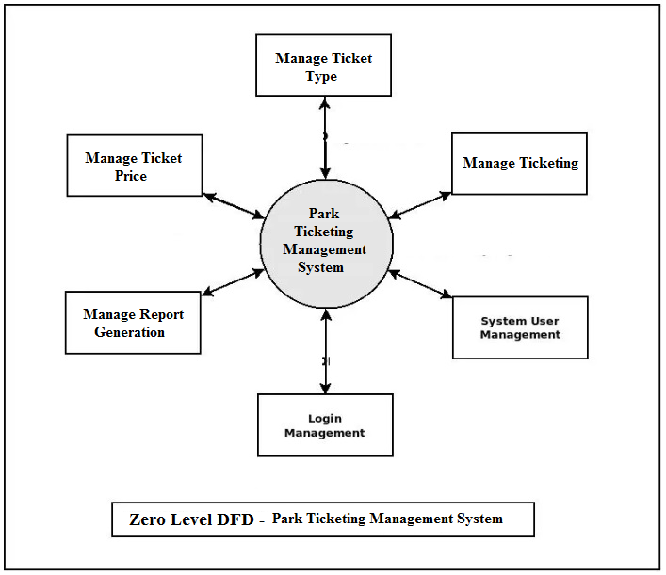

**Annexure B**

**Entity-Relationship Diagram (ERD)**

**(Mandatory)**

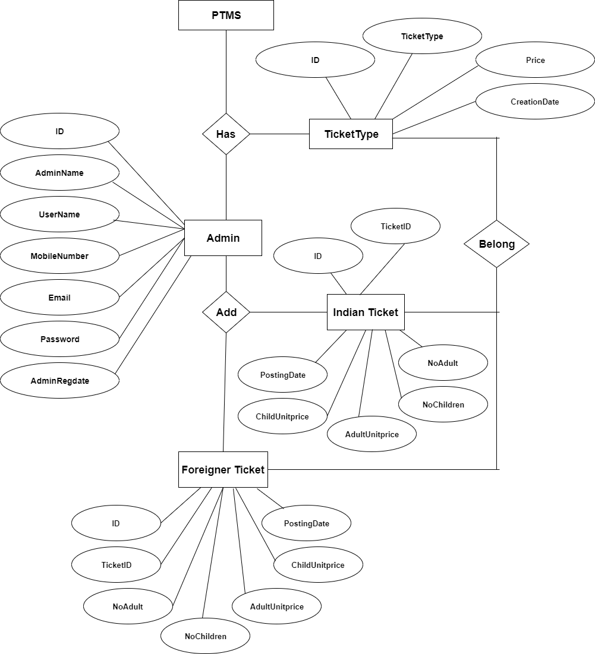

**Annexure C**

**Use-Case Diagram (UCD)**

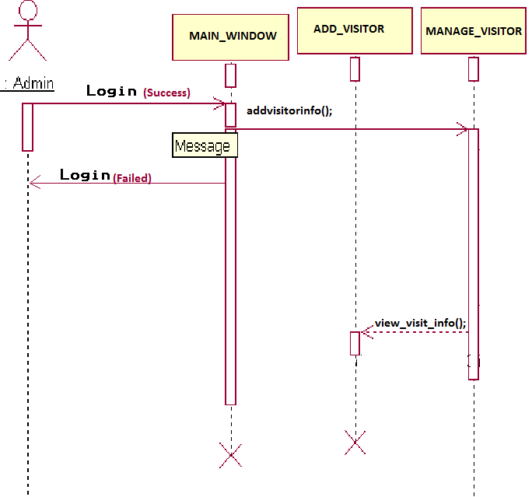

**SYSTEM**

**ADMIN**

**Sequence Diagram For Administrator:-**

**Annexure D**

**Data Dictionary (DD)**

**(Mandatory)**

**Example:**

**User Table (USR)**

|  |  |  |
| --- | --- | --- |
| **Fields** | **Data type** | **Description** |
| USR-Name | Text | Admin name |
| USR-Password | Text | Admin password |
| USR-Contact-No | Number | Admin Contact |
| USR-Address | Text | City |

**Supplier Table (SUPP)**

|  |  |  |
| --- | --- | --- |
| **Fields** | **Data type** | **Description** |
| SUPP-ID | Number | Supplier ID |
| SUPP-Name | Text | Supplier Name |
| SUPP-Address | Text | Supplier Address |
| SUPP-Contact | Number | Supplier Contact |
| SUPP-Credit-Limit | Number | Credit Limit |

**Annexure E**

**Screen Shots**